Dear [Name],

I would like to take advantage of an upcoming learning and development opportunity to attend an LMA improv class.

You may already know this, but improv is seriously good for business. In fact, several leading business journals that have written about this valuable training, including:

- Forbes: Can Improv Improve Marketing?
- CNN: Using Improv to Teach Business Skills is No Joke
- Fast Company: Improv Helps Corporate Team Building & Fuels Business Innovation
- Inc.: Improv Boosts Collaboration and Creativity
- Harvard Business Review: Change the Way Your Team Works

I have reviewed the topics and believe this workshop would have a very positive impact on my performance and wellbeing, and therefore, benefit our organisation.

Here are some skills we will receive by attending:

- Active Listening - responding to what’s being said, rather than your own agenda
- Taking initiative as a communicator and validating communication from others
- Being more aware of how specific word choice can affect your agenda
- Using the “Yes, and…” technique to contribute and build on other’s ideas
- Leveraging Divergent & Convergent Thinking to encourage creativity & innovate faster
- Making, and committing to decisions & being less afraid of mistakes
- Being less judgmental & avoiding unhealthy competition
- Eliminating the fear of public speaking and presenting

More information about LMA and their Corporate Training programs can be found at:
www.Laugh-Masters.com.au (School)
www.LMA.Training (Professional Development)

Attending this program will benefit me professionally, and have a very positive impact on our organisation. I genuinely appreciate you taking the time to read this proposal.

Best regards,

[Your Name]

Enc: Investment Levels

Investment Levels – 2019/2020

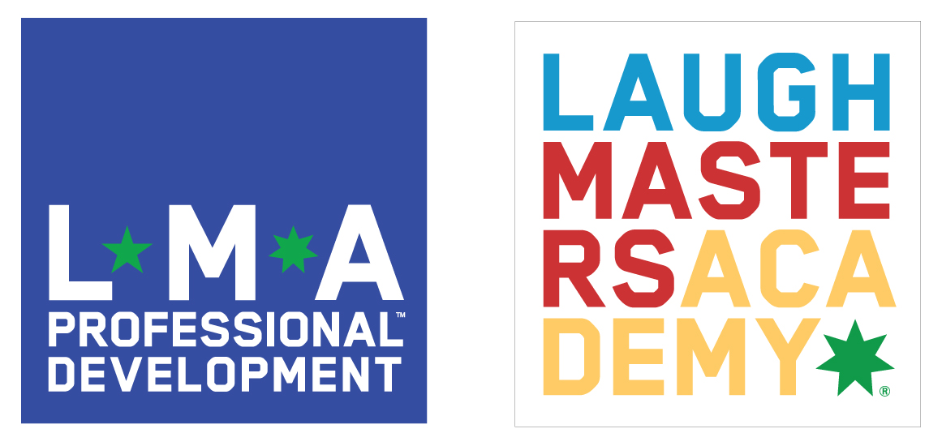
Individual Training
Sydney & Melbourne
Basic Improv Workshop
$489 +GST
Prices displayed per person.

More info:
www.laugh-masters.com.au

Corporate Training
Designed for teams from the same organisation.

Corp. Training rates can include a tailor-made program designed to address specific areas of focus, pain points, needs etc. as they relate to you and your business.

There are a number of elements that affect the level of investment you’ll make in this effective training: Size of group, number of Facilitators required, location, length, and level of customisation if any.

If you’re working with a specific budget let us know and we can chat through the options.

More info:
www.lma.training

Contact: yes@lma.training

